**UNIX LAB ASSIGNMENT 1**

Name: Sreekesh Iyer Class/Roll No: D10A/24

1. **Stepwise Installation of Ubuntu**  
     
   1. **Downloading the Disk Image File of Ubuntu:**   
     
    Download the disk image file (.iso file) of Ubuntu’s latest version from its proprietary website. It’ll take some time as the file is around 2.6 GB in size.  
     
   2. **Create a USB flash drive:**  
    You need a USB-removable disk of at least 4GB for this, flash the ISO file on to this flash drive. Now we will install Ubuntu using this flash drive.  
     
   3. **Changing Boot Priority:**  
      
    To Install Ubuntu from the USB flash drive onto your device, we’ll have to boot into the USB flash drive, which will hence trigger the installation. Restart your PC, press the Delete or F12 key in the BIOS screen to open the BIOS setup. Next up, go to the Boot settings and give #1 priority to the USB flash drive which is already plugged in. Also, it’s recommended to only have a single storage device (the one in which the OS is to be installed) connected to the system.   
     
   4. **Installing Ubuntu:  
    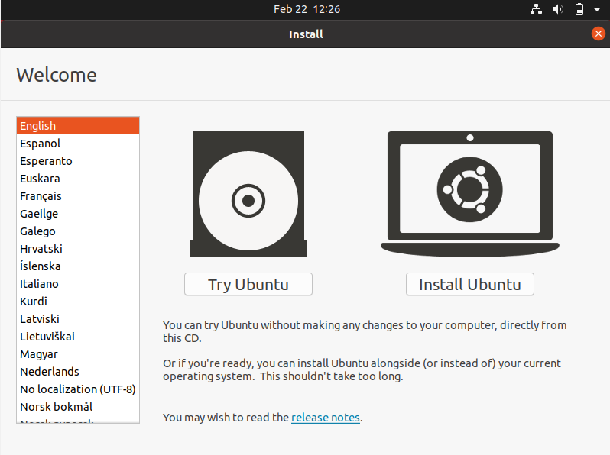** Once you boot into the flash drive, you’ll come to the Ubuntu install screen. First up, you get to choose the language and whether you want to *Try* or *Install* Ubuntu. Proceed with *Install Ubuntu*.   
   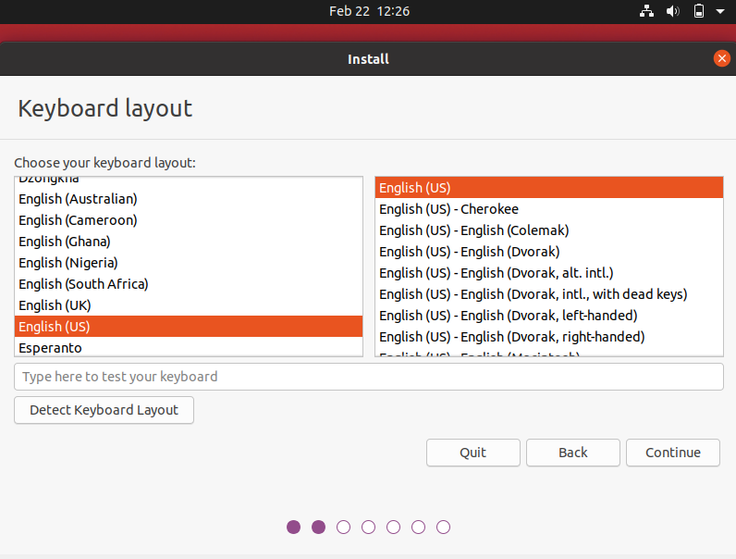  
    Next up, choose your Keyboard Layout and Language, you can also test your keyboard and its working in the text box below.  
   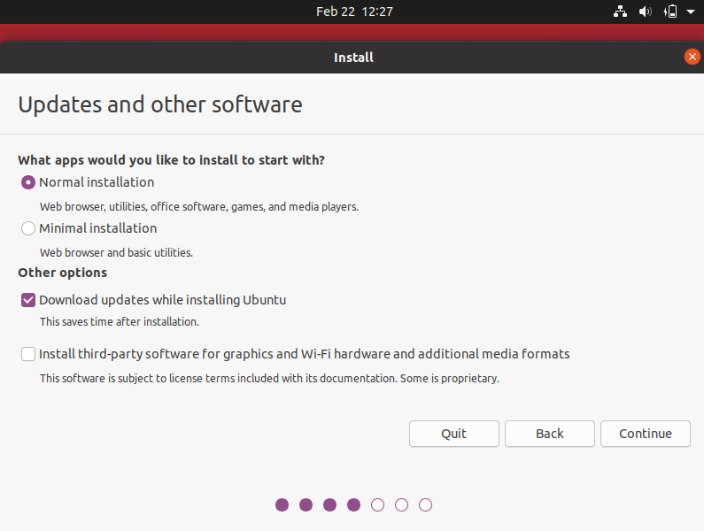  
    Proceeding forward, choose your default apps, let’s proceed with *Normal Installation* which includes all default utilities along with office software, games, etc.   
   You can also choose whether you want to install the latest updates while installing Ubuntu and install third-party software for WiFi and other media formats.   
   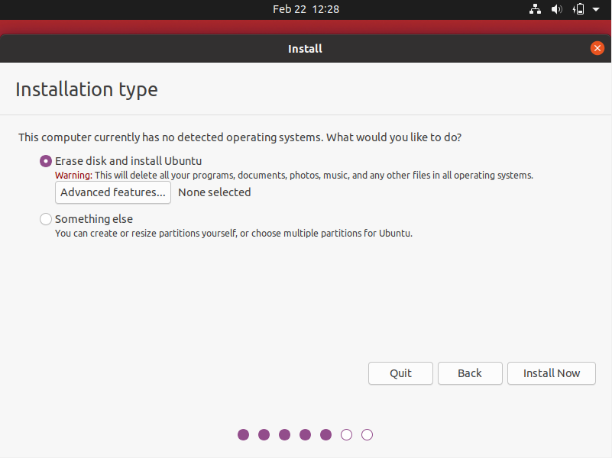  
    Then, allocate the empty partition of your disk to the system, where Ubuntu will be installed. Keep in mind if this disk has any data, it’ll be erased. Click on *Install Now*.   
   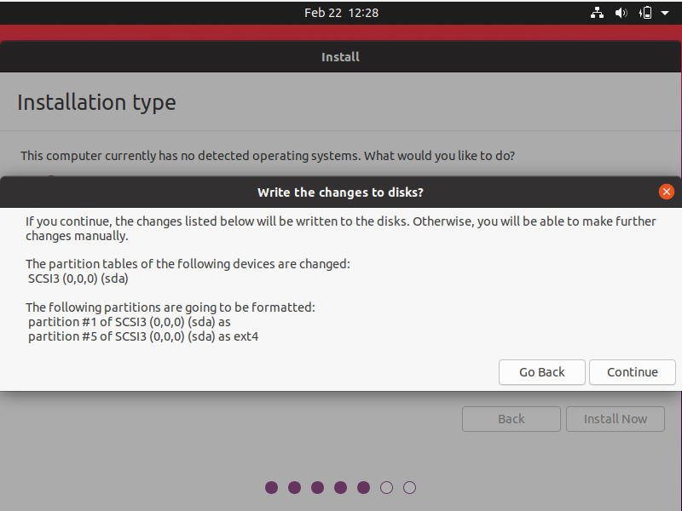  
   Once again, it’ll confirm the disk and partition names that will be used for installation. Proceed with the installation by clicking *Continue.*   
   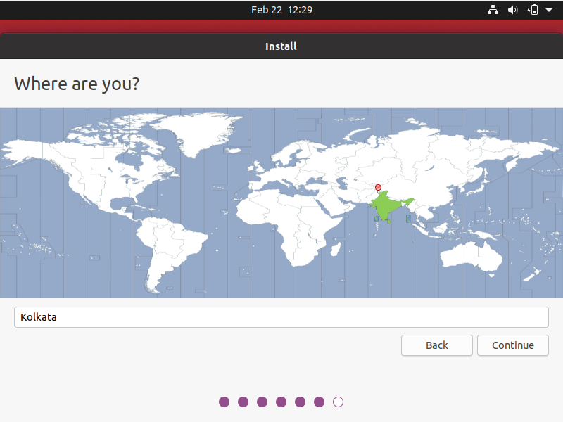  
   Select your location, it shows a location by default, if not accurate, you can enter your location in the text box given below.   
   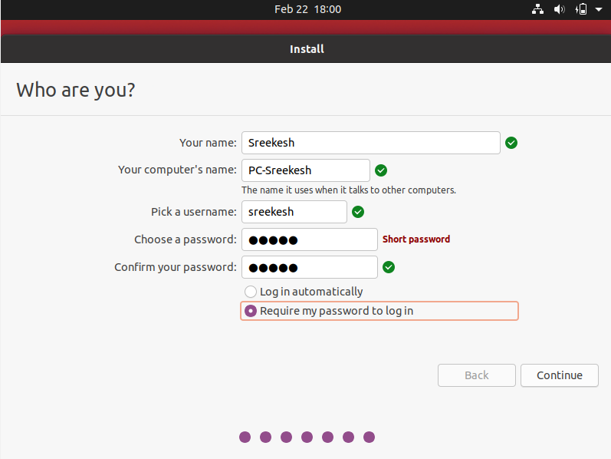  
   Lastly, unlike Windows, Linux asks you to create a user account before Installation. So enter your credentials (this will be needed on startup), choose a suitable username and a strong password. When you click *Continue*, the installation will start.   
   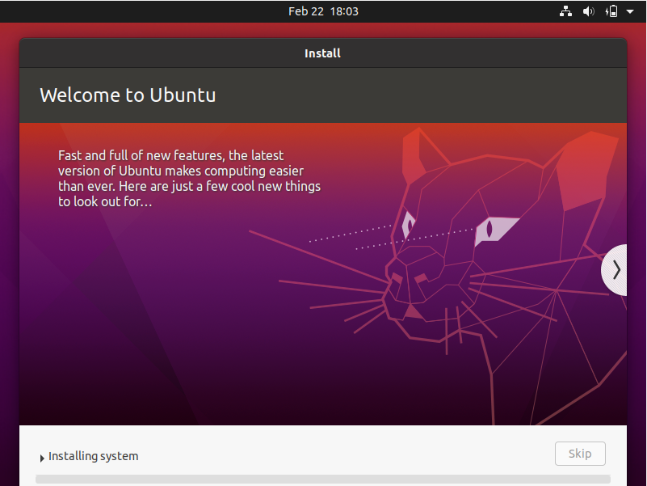  
     
   This process will take roughly 20 minutes depending on the sequential read-write speeds of your storage device. Typically this process is quicker on an SSD.   
   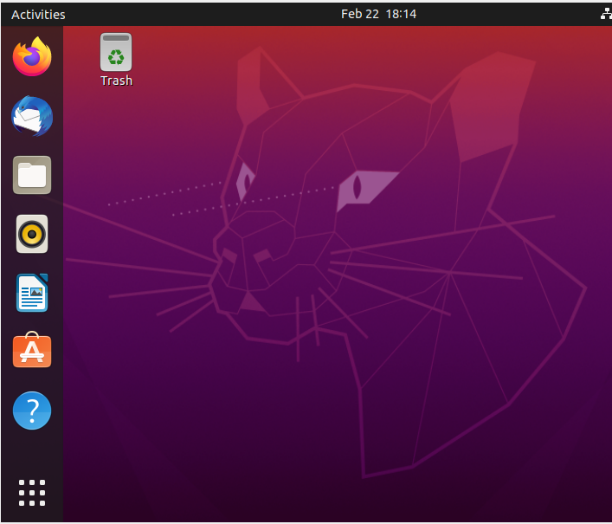  
   Once done, it’ll prompt you to restart the system and will boot to Linux. Enter your credentials and here you are, with Ubuntu successfully installed on your machine.
2. **Short Note on Unix Architecture**  
     
   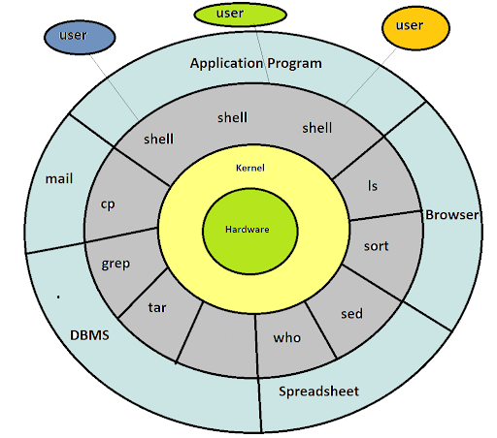  
     
   Unix has a Graphical User Interface similar to Windows that makes it easy for navigation and a good supportive environment. The internal design view of this OS can be known from its architecture.  
     
   The architecture of this OS is four-layered. It consists of *Hardware, Kernel, System Call Interface (Shell)* and *Application Libraries/Tools/Utilities, etc.* The kernel controls the hardware of the computer and resides in the core of the architecture. System calls act as the interface between the kernel and other libraries. These libraries include general functions and are built on top of the system calls. Shell is a special application that provides an interface to the other applications of the architecture.   
     
   **Kernel:**   
     
   For Unix, Kernel is the central core that interacts directly with system hardware.   
   The main functions of the kernel are -   
   1) Controlling Computer hardware such as memory, disks, printers, etc.   
   2) Scheduling processes, controlling and execution of various user-defined tasks.  
   3) Managing the data storage and controlling the computer accessed by different users.  
   **Shell:**Shell is an interface between the user and the kernel. Users can interact with the shell by using shell commands. Shell has two main responsibilities which include interpreting the commands given by the users and executing them using the kernel, providing programming ability to the users to write shell commands for a shell script to perform specific tasks.  
     
   **Properties of Unix:**Unix plays a big role in many data centres and research labs. Some of the properties of Unix, preferable over other systems are -   
   1) Multi-user accessing - Multiple users can work on the system simultaneously.  
   2) Multi-Tasking - It provides the facility to run multiple programs or processes by users on one system.  
   3) Portability - It provides the flexibility to be used on multiple hardware architectures. It is easy to modify Unix code according to the hardware of the computer.   
   4) Communication: Requests and commands given by a user are carried out by the kernel and shell together. It provides inter-system communication and also obeys TCP/IP.   
   5) File Maintenance is easy, Unix provides support for a wide variety of software for development and maintenance.
3. **Difference between Linux and Windows Operating systems.**

| **Linux** | **Windows** |
| --- | --- |
| Linux is open source, thus free to use. | Windows is not open source, it comes as a paid software, Windows 10 Pro costs roughly around 139 USD. |
| Linux File System is Case Sensitive.  Linux Directories are separated by forward-slash. ‘/’ | Windows File System is not Case Sensitive. Windows Directories are separated by backwards-slash. ‘\’ |
| Linux uses Monolithic Kernel. | Windows uses a micro-kernel. |
| Linux is more efficient as compared to windows when it comes to performance in different operations. | Windows is less efficient as compared to Linux when it comes to performance. |
| Linux is very secure as it is easy to detect and fix bugs. | Windows has a huge user base, thus becoming vulnerable to different cyber attacks. |

**The difference in Architecture of Linux and Windows:**

